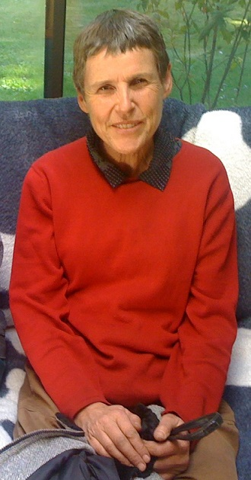
Meadow Farm History

Meadow Farm Community Land Trust MFCLT is a 501(c)3 charitable organization created in 2013. The founder, Joanna Becker, (pictured) had a vision to create a small community of rural housing for low to moderate income people dedicated to a sustainable way of life and volunteerism. Under this designation the land will be held in perpetuity for this purpose only.

When Joanna purchased the nearly 28 acres in 2010 from the Matilla family, the only development was the cleared land we now call the meadow.The Matilla family logged and grew potatoes, oats and hay on the land during the previous 100 years. The south boundary follows the north rim of Pudding Creek basin for approximately a mile and lies about 2 miles east of the ocean just north of Fort Bragg. The property has a long narrow beginning and end with the 6 area meadow filling out the middle section.

Joanna began with a 280 foot well, a septic system and a house that she begin constructing with wood logged and milled from the land. Meanwhile she spent the fall times with her family in England and then on to Costa Rica, where she was developing another charitable property. In the spring she would return to Meadow Farm.

In March of 2014 Jesse Stafford and Sojourna Lee were invited to the land. They began to expand the small garden area and work on other projects. A board of directors worked with Joanna on legal affairs of the CLT. In August of 2015 Joanna turned ownership of the land over to the board to manage for the future of Meadow Farm CLT and organizational matters. Soon after that board resigned and a new board of three was selected by Joanna.

On August 6, 2016 Joanna passed away in the emergency room at the local hospital. It was a shock, a sad and tumultuous time ensued. The new board of directors were left to piece together the non-profit status and other crucial matters that were under development by Joanna.
Overcoming many challenges along the way the new board continued to work diligently to maintain the 501(c)3 status and honor Joanna’s vision as much as was known and possible.

Over the years the board and residents added their own ideas and abilities toward creating a successful community where people could thrive in a healthy environment and be a benefit to the coastal area. The Board of Directors is also known as the Leadership Circle and uses a form of consent decision making governance called Sociocracy,

Meadow Farm now has a population of 4 to 8 depending on the season and number of traveling volunteers present from a program called Workaway. Jesse and Sojourna are now considered permanent residents and may legally hold a 99-year lease on their respective homes. The board and residents look forward to the creation of new homes for future community members.

During 2020 the organization completed construction on Joanna’s existing community house. 5000 gallons of water storage and a fire hose valve was adde. Disaster preparation and sheltering programs are in the works and Meadow Farm became a “Public Hub” through Hubs and Routes program ( www.hubsandroutes.net ). Carbon sequestering is improved as the farm completed its 3rd year of the Healthy Soils Program from a USDA grant.

As Meadow Farm enters its second decade the board and residents are grateful for the strong foundation created by Joanna, and all who have given so much of their heart and hands, to carry forward the Vision, Mission and Aims for a peaceful and sustainable future for our coastal community.

